Contact person: Temirbek Zhenisgul  Safety Engineer LLP «Zhol-Sapa»  Tel.: +7 705 596 71 34 |  | road-traffic safety

press release

Working meeting chaired by Head of the Administrative Department of the Department of Internal Affairs of Aktobe Region
«Provision of traffic safety during reconstruction of road section A-27 “Aktobe – Atyrau – br. of RF (to Astrakhan)”

Road traffic safety plays no small role in the construction of highways. This is a state of the road, reflecting the degree of protection of its participants and the state from road accidents and their consequences.

In pursuing these aims, a working meeting was held on February 14, 2018 at 10:00 local time, in the city of Aktobe, chaired by Altynbaev Erlan Kalaubayevich, the police colonel, the head of the Administrative Department of the Department of Internal Affairs of Aktobe Region, to ensure the road traffic safety during the construction of road on sections km. 160-220 (Shubarkudyk village), km. 236-275 (Karauylkeldi village) and km. 275-330 (Nogait village) and to protect road users and residents, who lives along the road.

The meeting was attended by Construction Supervision Consultants from international company LTD “Dongsung Engineering CO.”, (Korea) and local company LLP “Zhol Sapa” (RK), heads of Contractors, who directly carry out construction work - "Todini Construzioni Generali S.p.A" "(Italy) and" OJCS ACCORD "(Azerbaijan).

Issues were considered regarding road safety, preventive measures of accidents at sites, medical organizations, what kind of Logbooks should be kept, what measures should be taken in the event of an accident, etc.

According to the decision of the working meeting, the head of the Administrative Department of the Department of Internal Affairs gave instructions to the head of the DRTI (Department of Road and Technical Inspections), to the heads of the Temir and Baiganyn regions and to the Contractors.

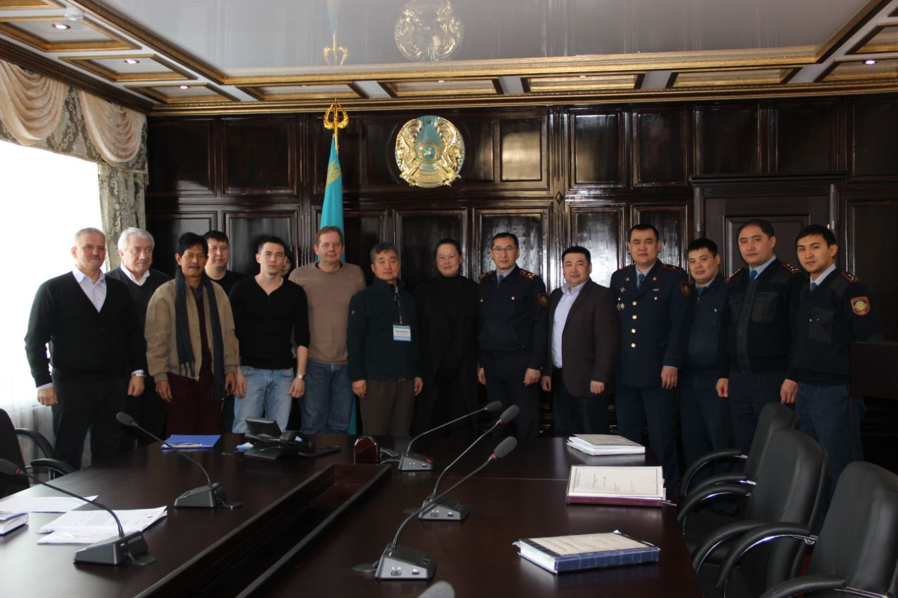
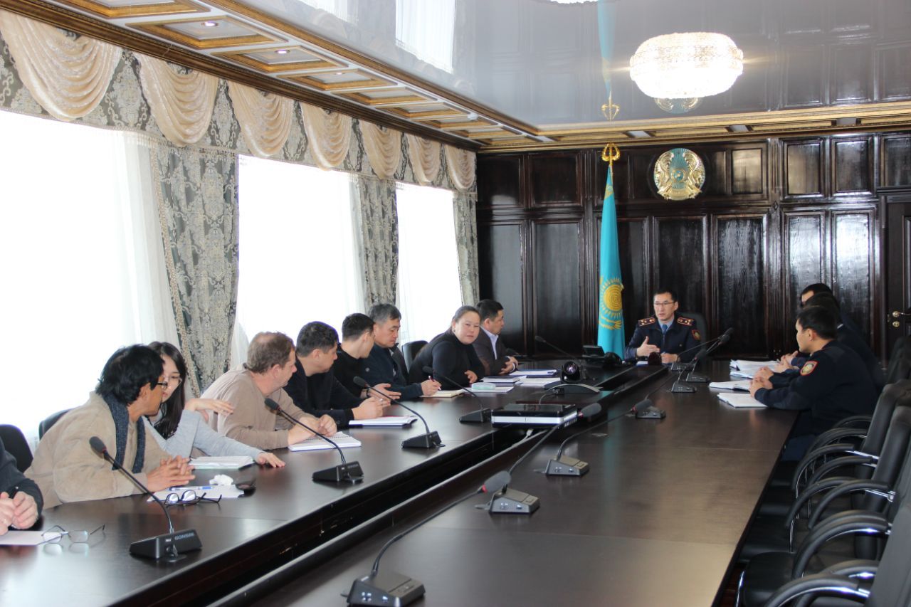
Photo report of the working meeting, which took place on 14.02.2018 in the assembly hall of the Administrative Department of the Department of Internal Affairs of the Aktobe region

